Lab 2: Exercises

Exercise 1:
What will be your choice if you were faced with the following criteria/choices?

Fill in the table with ticks and crosses (when more than ticks put a preference in terms of 1,2 and 3)
(Note: This is your subjective view as it is difficult to find right or wrong answer to this questions; you still have to justify your choices).

Criteria  (e.g. App requires these features) | Native | Hybrid | Web
Example:  Native functions (camera, storage, accelerometer) | √ (1) | √ (2) | ×
Performance
Heavy use of Graphics
Excellent user interaction
Gestures (multi-touch, double tap)
Support for all platforms
App store deployment
High Discoverability, SEO
Low Installation Hassle
Low Maintenance
Easy approval process and No/Minimum Fees
Online and Offline Connectivity
Minimum Development Time
Minimum Effort
Minimum Spending/Budget

Some useful links:

https://developer.salesforce.com/page/Native,_HTML5,_or_Hybrid:_Understanding_Your_Mobile_Application_Development_Options
http://smartbridge.com/the-mobile-development-conundrum-native-vs-hybrid-app-development/
https://www.facebook.com/notes/facebook-engineering/under-the-hood-rebuilding-facebook-for-ios/10151036091753920

http://www.html5rocks.com/en/mobile/nativedebate/

http://www.theguardian.com/media-network/media-network-blog/2013/feb/07/html5-native-apple-android-strategy

http://readwrite.com/2012/08/23/how-facebook-ditched-the-mobile-web-went-native-with-its-new-ios-app#awesm=~o9jDrRefxdgnpS

http://www.nngroup.com/articles/mobile-native-apps/

Exercise 2:
Step 1:
- Open Android Studio.
- Click on File option in Android Studio menu bar
- Click on the "New Project" window that opens
- Make sure on that "Phone and Tablet" is the only box that is checked.
- Select "Empty Views Activity."
- Click "Next."
- Give a name to your mobile application.
- Note where the project file location is and change it if desired
- Make sure to select Java Language.
- Leave all the Activity fields as they are.
- Click "Finish."

Step 2:

- Navigate to the activity_main.xml tab if it is not already open.
- Make sure that the Design tab is open on the activity_main.xml display.
- Click on Code tab to open it.
- the activity_main.xml file will open in editable window.
- In this file, find the line "Hello world!".
- After the "Hello world!" message, add "Welcome to my app!"
- Navigate back to the activity_main.xml tab, and select Design tab
- Make sure that your cantered text now reads "Hello world! Welcome to my app!"

Step 3:
To run your Mobile application, we need to select the emulator (mobile device)
- Double click on Device Manger option (see below)

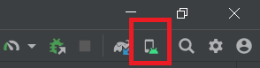

- Click on add a new device
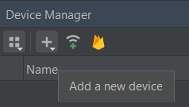
- Select “Create Virtual Device” option
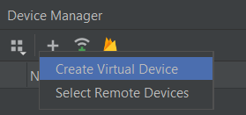
- Choose any device that you like depending on the resolution and density
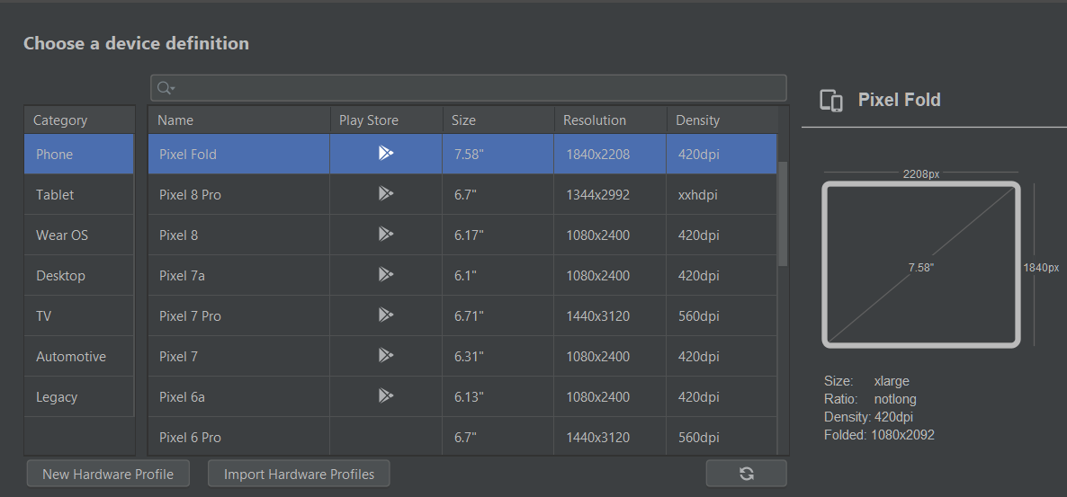
- Click "Next."
- Then click “Next” again
- Click “Finish”

Step 4:
- Click on Run option in Android Studio menu bar
- Click on “Run app” option
- Wait until the mobile emulator will appear.
- Sometimes, you will get some error messages which are related to the version SDK, or to AGP

Exercise 3
Step 1:
- Navigate to the Design tab of the activity_main.xml display.
- In the Palette menu to the left of the phone display, find Button option.
- Click and drag Button to be centered underneath your welcome message.
- Make sure your button is still selected.
- In the Attributes menu (on the right side of the window), scroll down to find the field for "text."
- Change the text from "Button" to "Click Me!"

Step 2:
  - Select the MainActivity.java tab along the top of the work environment.
  - Add the following lines of code before the end of the onCreate method:
Button button = findViewById(R.id.button);
button.setOnClickListener(new OnClickListener() {
@Override
public void onClick(View v) {
mytext.setTextSize(22);
mytext.setTextColor(Color.BLUE);
}
});

Step 3:
- Click on Run option in Android Studio menu bar
- Click on “Run app” option
- Wait until the mobile emulator will appear.
- When the Mobile appears.
- Click on the button “Click Me!”
- You will see the changes in size and colour of your message.
Step 4:
- Now, we need to centralise the button “Click Me!” underneath your welcome message

Exercise 4
Step 1:
- Open Android Studio.
- Click on File option in Android Studio menu bar
- Click on the "New Project" window that opens
- Make sure on that "Phone and Tablet" is the only box that is checked.
- Select "Empty Views Activity."
- Click "Next."
- Give a name to your mobile application.
- Note where the project file location is and change it if desired
- Make sure to select Java Language.
- Leave all the Activity fields as they are.
- Click "Finish."

Step 2:
- Navigate to the Design tab of the activity_main.xml display.
- In the Palette menu to the left of the phone display, find TextView option.
- Click and drag TextView to be left side and underneath mobile menu.
- Make sure your TextView is still selected.
- In the Attributes menu (on the right side of the window), scroll down to find the field for "text" and give a name such as “Enter the mount”
- In the Palette menu to the left of the phone display, find PlainText option.
- Click and drag PlainText to be in the front of “Enter the mount” TextView.
- Make sure your PlainText is still selected.
- In the Attributes menu (on the right side of the window), scroll down to find the field for “id” and give a name as “ed_Decimal”, also fine "hint" filed and give a name such as “Enter Decimal number”.

- In the Palette menu to the left of the phone display, find TextView option.
- Click and drag TextView to be underneath “Enter the mount” TextView.
- Make sure your TextView is still selected.
- In the Attributes menu (on the right side of the window), scroll down to find the field for "text" and give a name such as “£50”
- In the Palette menu to the left of the phone display, find TextView option.
- Click and drag TextView to be in the front of “£50” TextView.
- Make sure your TextView is still selected.
- In the Attributes menu (on the right side of the window), scroll down to find the field for "id" and give a name such as “txt50”

- In the Palette menu to the left of the phone display, find TextView option.
- Click and drag TextView to be underneath “£50” TextView.
- Make sure your TextView is still selected.
- In the Attributes menu (on the right side of the window), scroll down to find the field for "text" and give a name such as “£20”
- In the Palette menu to the left of the phone display, find TextView option.
- Click and drag TextView to be in the front of “£20” TextView.
- Make sure your TextView is still selected.
- In the Attributes menu (on the right side of the window), scroll down to find the field for "id" and give a name such as “txt20”

- In the Palette menu to the left of the phone display, find TextView option.
- Click and drag TextView to be underneath “£20” TextView.
- Make sure your TextView is still selected.
- In the Attributes menu (on the right side of the window), scroll down to find the field for "text" and give a name such as “£10”
- In the Palette menu to the left of the phone display, find TextView option.
- Click and drag TextView to be in the front of “£10” TextView.
- Make sure your TextView is still selected.
- In the Attributes menu (on the right side of the window), scroll down to find the field for "id" and give a name such as “txt10”

- In the Palette menu to the left of the phone display, find TextView option.
- Click and drag TextView to be underneath “£10” TextView.
- Make sure your TextView is still selected.
- In the Attributes menu (on the right side of the window), scroll down to find the field for "text" and give a name such as “£5”
- In the Palette menu to the left of the phone display, find TextView option.
- Click and drag TextView to be in the front of “£5” TextView.
- Make sure your TextView is still selected.
- In the Attributes menu (on the right side of the window), scroll down to find the field for "id" and give a name such as “txt5”

- In the Palette menu to the left of the phone display, find TextView option.
- Click and drag TextView to be underneath “£5” TextView.
- Make sure your TextView is still selected.
- In the Attributes menu (on the right side of the window), scroll down to find the field for "text" and give a name such as “Coins”
- In the Palette menu to the left of the phone display, find TextView option.
- Click and drag TextView to be in the front of “£5” TextView.
- Make sure your TextView is still selected.
- In the Attributes menu (on the right side of the window), scroll down to find the field for "id" and give a name such as “txtcoins”

- In the Palette menu to the left of the phone display, find Button option.
- Click and drag Button to be centred underneath your last TextView “Coins”.
- Make sure your button is still selected.
- In the Attributes menu (on the right side of the window), scroll down to find the field for "text."
- Change the text from "Button" to "Convert!" (See the below)

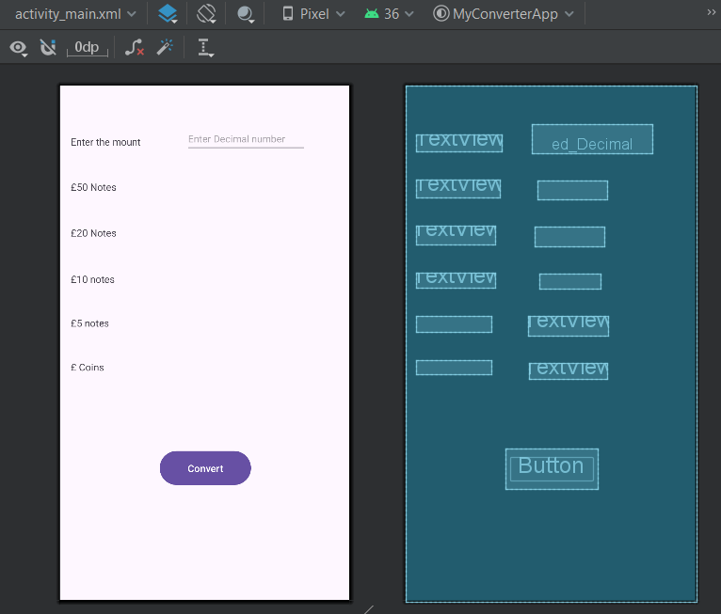

Step 3:
  - Select the MainActivity.java tab along the top of the work environment.
  - Add the following lines of code before the end of the onCreate method:
EditText ed_Decimal =( EditText ) findViewById(R.id.ed_Decimal);
TextView txt50 = (TextView ) findViewById(R.id.txt50);
TextView txt20 = (TextView ) findViewById(R.id.txt20);
TextView txt10 = (TextView ) findViewById(R.id.txt10);
TextView txt5 = (TextView ) findViewById(R.id.txt5);
TextView txtcoins =(TextView ) findViewById(R.id.txtcoins);

Button button = findViewById(R.id.button);
button.setOnClickListener(new OnClickListener() {
@Override
public void onClick(View v) {
/** Copy the code from Lab1 and insert it here **/
/** Change the following codes from Lab1 **/
Scanner sc = new Scanner(System.in);
System.out.println("Enter your money");
int a = Integer.parseInt(sc.nextLine());
to
double num = Double.parseDouble(ed_Decimal.getText().toString());

/** Change every System.out.print (); into for example
txt50.setText(); for £50 notes, the repeat for txt20, txt10, and txt5. While for txtcoins you need to use the following
txtcoins.setText(String.format(“%.2f”, new BigDecimal());

}
});

see the final Mobile App

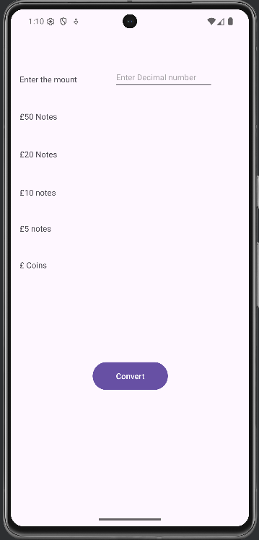 | 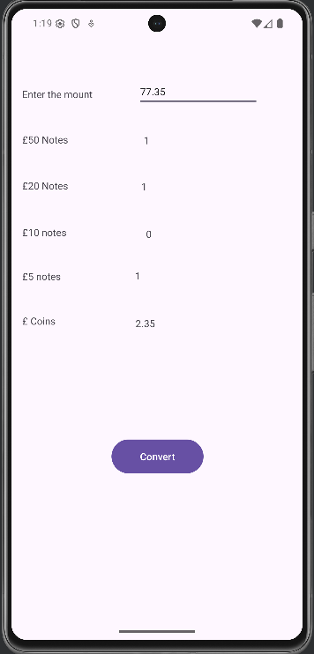

Exercise 5
Adding debugging log to your Mobile App.
Step 1:
- Add the following line to your java code under import statemes

import android.util.Log;
- add the following code before onCreate() method
private static final String TAG = MainActivity.class.getSimpleName();
- Add the following code before the end of onCreate() method
Log.d(TAG, “onCreate() …”);
- Add the following code before the end of onClick() method
Log.d(TAG, “onClick() …”);

Step 2:
  - Run you Application
  - Open LogCat pane (window) see below

